System & Managed Identity

1. **Azure AD B2C**:  
   Azure AD B2C is an identity management service for authenticating external users (e.g., customers in an e-commerce app). It is used for scenarios where end-users need to sign up, sign in, and manage their accounts.
2. **User-Assigned Managed Identity**:  
   A User-Assigned Managed Identity is an Azure feature for **resource-to-resource authentication**, allowing Azure resources (like APIs or apps) to securely access other Azure resources (like SQL Server, Key Vault) without storing credentials.

• **Azure AD B2C**: Used to manage **customers** of your e-commerce app, enabling them to log in, sign up, and manage their profiles.

• **User-Assigned Managed Identity**: Used for **backend authentication** to secure communication between Azure resources, such as:

* Your e-commerce API accessing an Azure SQL Database to fetch product or order data.
* Your API retrieving secrets (e.g., connection strings) from Azure Key Vault.

• **For Customer Authentication (Frontend)**:

* Use **Azure AD B2C** to handle customer logins and profile management.
* Example: A customer signs into your e-commerce app to view their order history.

• **For Secure Backend Access (APIs and Databases)**:

* Use **User-Assigned Managed Identity** to securely connect your API (hosted in Azure) to Azure SQL Database or Azure Key Vault.
* Example: Your API fetches order data from the database using a managed identity instead of storing a username/password in code.

• **User**: Ideal for interactive access by humans. Requires credential management.

• **System-Assigned Managed Identity**: Best for resource-specific access without the need for shared credentials. Tied to a resource's lifecycle.

• **User-Assigned Managed Identity**: Best for shared or reusable access scenarios across multiple resources, offering flexibility and independence.

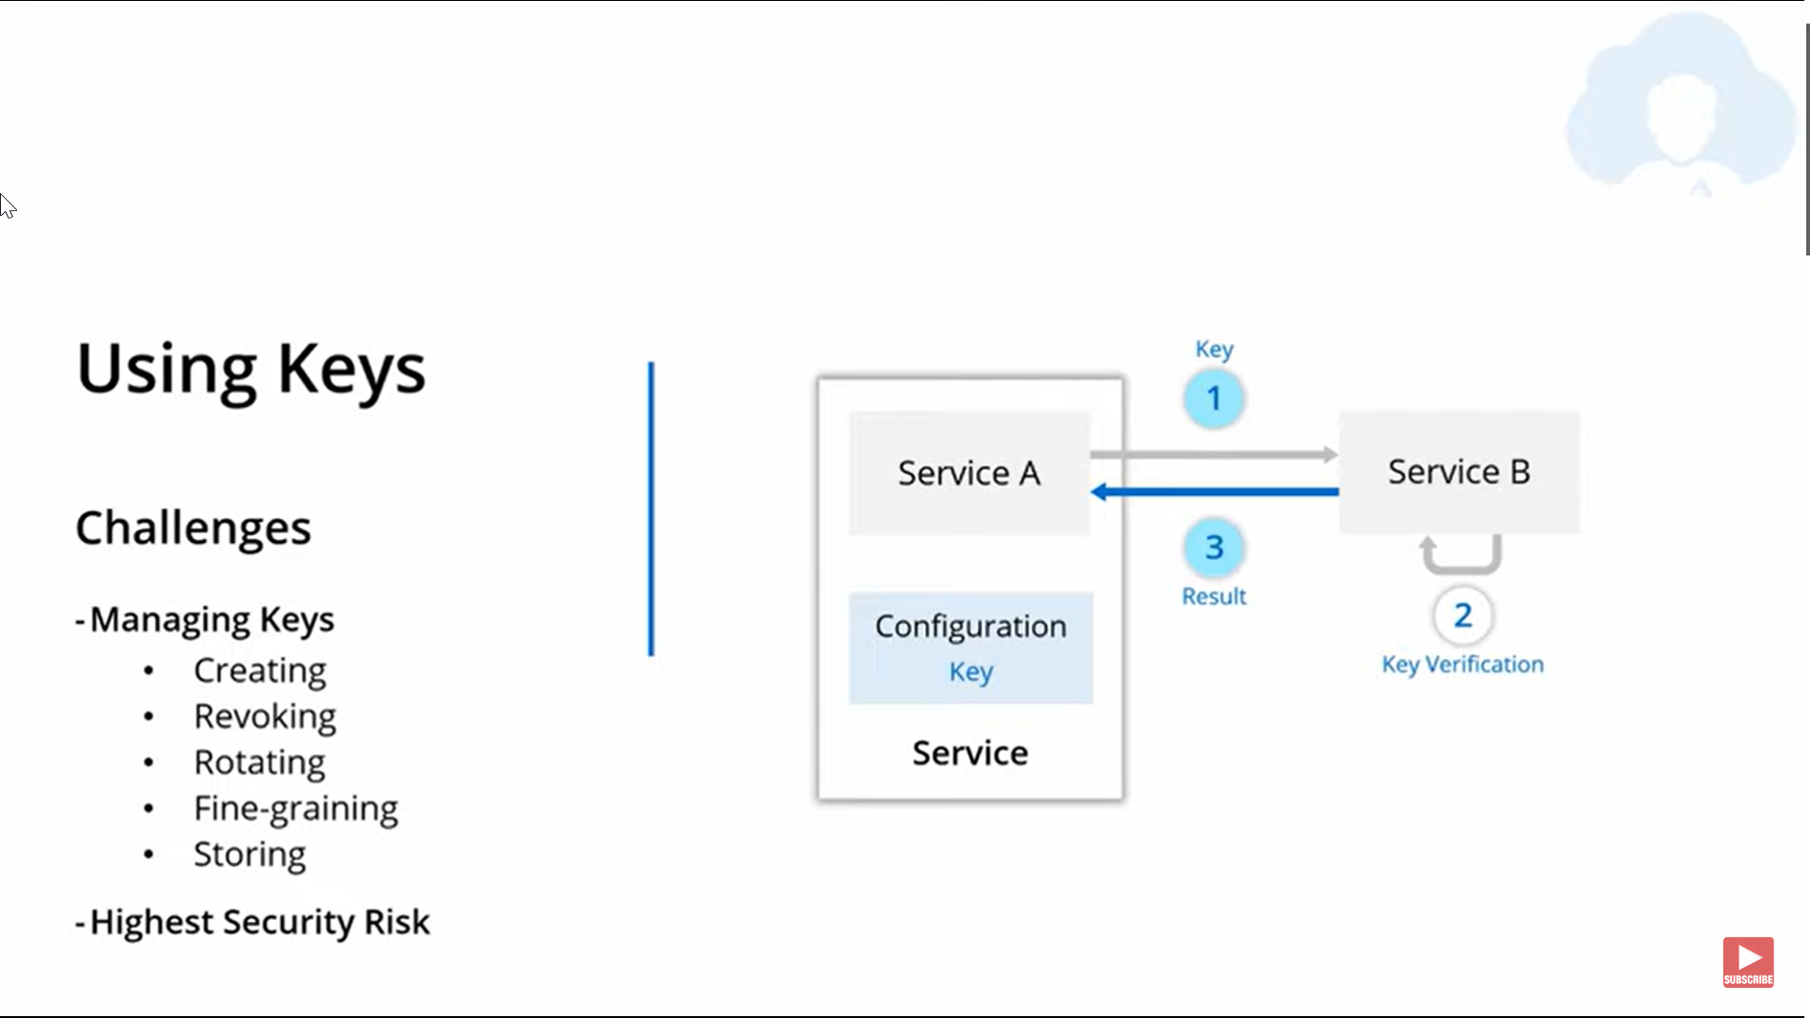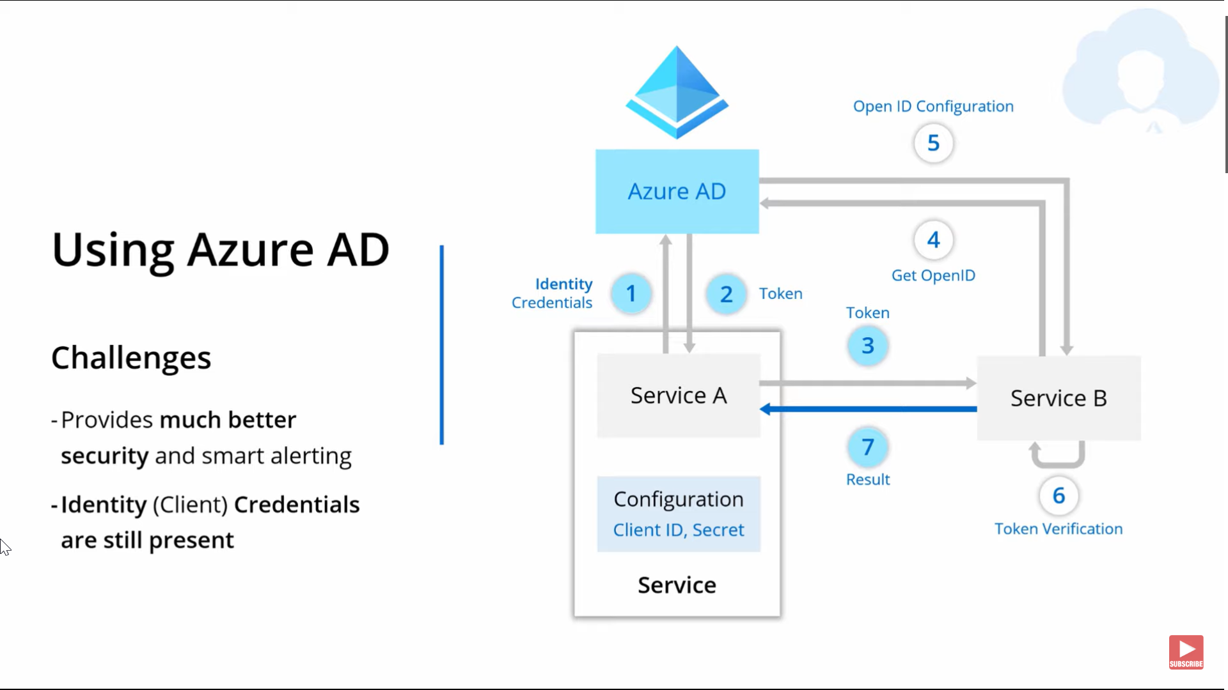

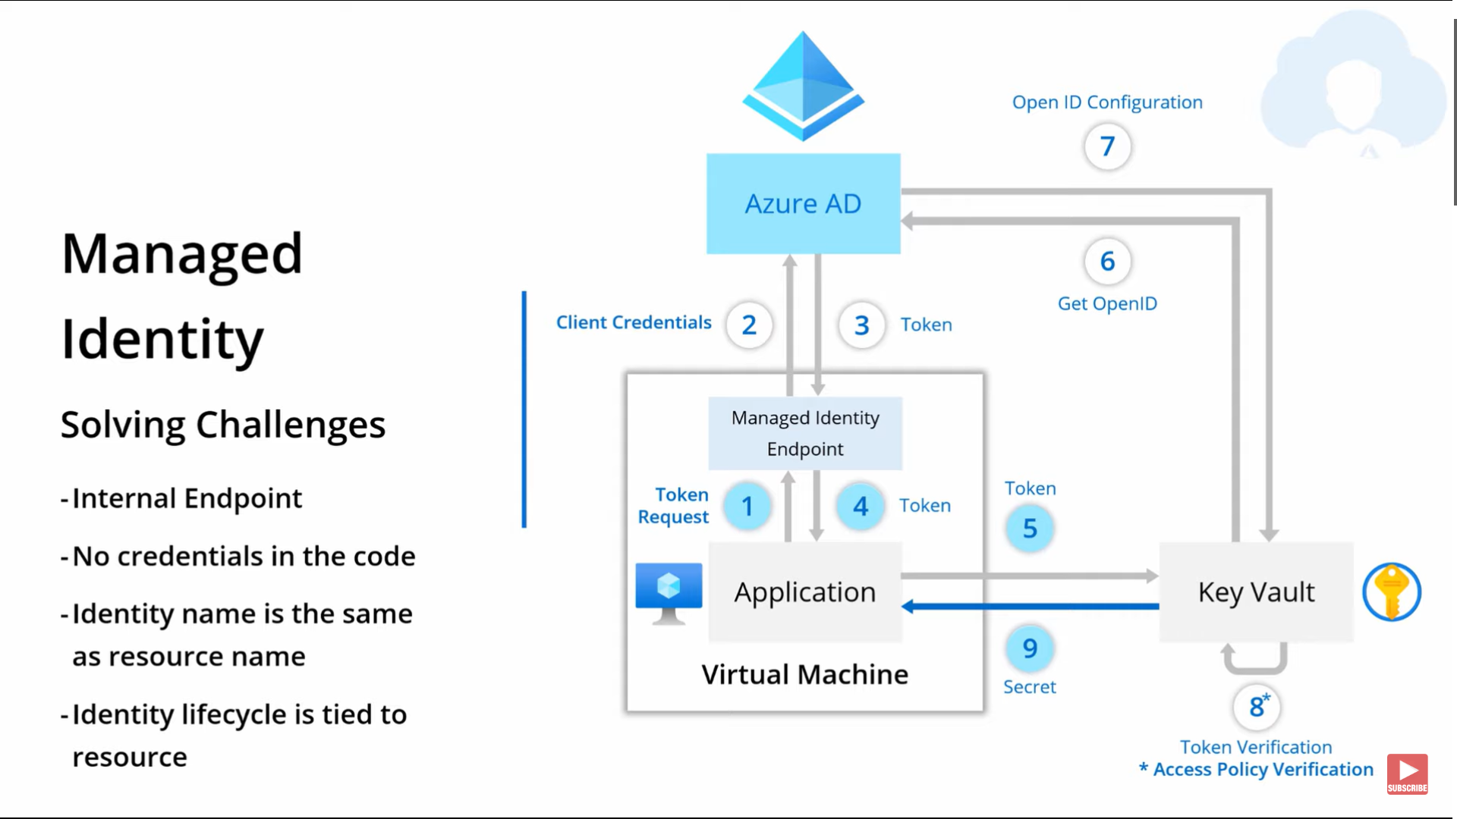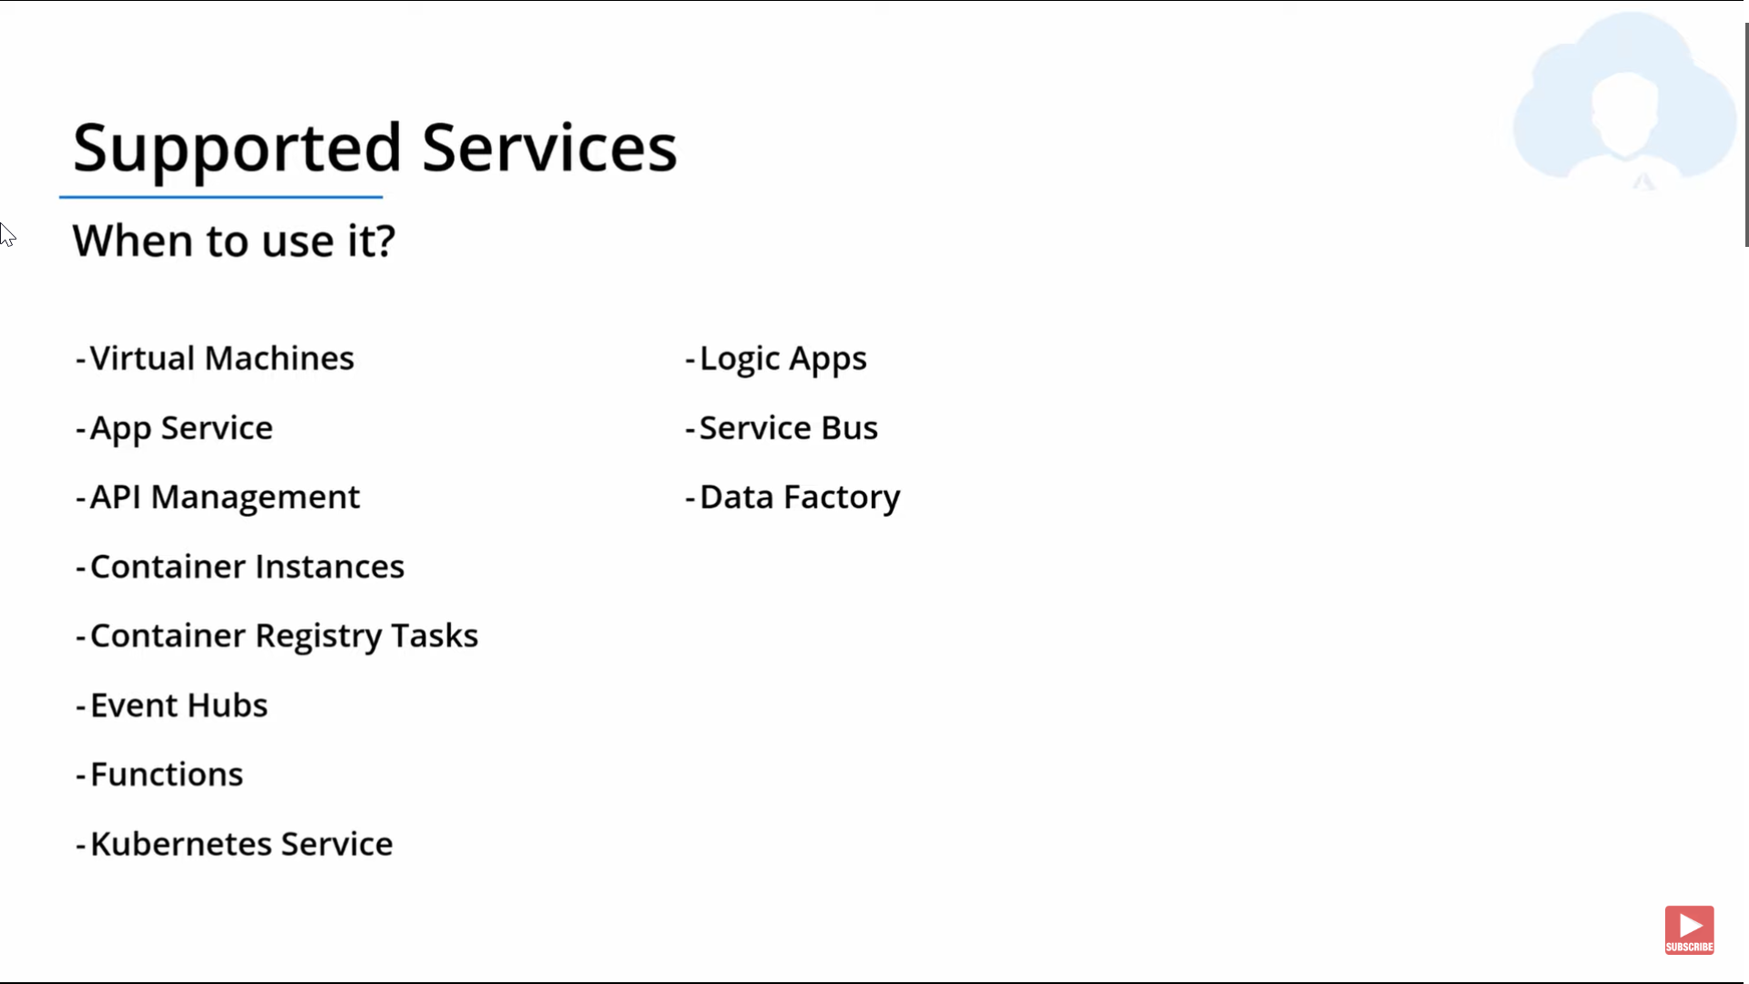

|  |  |
| --- | --- |
|  |  |
| public class Employee  {  public string Name { get; set; }  public int Age { get; set; }  public virtual decimal CalculateSalary()  {  // Base salary calculation for a generic employee.  return 3000;  }  }  public class PermanentEmployee : Employee  {  public decimal Bonus { get; set; }  // Overriding method but introducing incorrect behavior  public override decimal CalculateSalary()  {  // Adding bonus for permanent employees, but not accounting for contract employees  return base.CalculateSalary() + Bonus;  }  }  public class ContractEmployee : Employee  {  public decimal ContractAmount { get; set; }  // Overriding method with different behavior for contract employees  public override decimal CalculateSalary()  {  // Contract employees' salary calculation  return ContractAmount;  }  } | public abstract class Employee  {  public string Name { get; set; }  public int Age { get; set; }  // Define a common method signature  public abstract decimal CalculateSalary();  }  public class PermanentEmployee : Employee  {  public decimal BaseSalary { get; set; }  public decimal Bonus { get; set; }  // Permanent employee salary includes bonus, but respects the base method signature  public override decimal CalculateSalary()  {  // Return salary as base salary + bonus for permanent employees  return BaseSalary + Bonus;  }  }  public class ContractEmployee : Employee  {  public decimal ContractAmount { get; set; }  // Contract employee salary comes from the contract amount  public override decimal CalculateSalary()  {  // Return contract amount for contract employees  return ContractAmount;  }  } |
| public class PayrollSystem  {  public void ProcessSalary(Employee employee)  {  decimal salary = employee.CalculateSalary();  Console.WriteLine($"Salary for {employee.Name} is {salary}");  }  }  // Usage  Employee permanentEmployee = new PermanentEmployee { Name = "John", BaseSalary = 4000, Bonus = 500 };  Employee contractEmployee = new ContractEmployee { Name = "Jane", ContractAmount = 3500 };  PayrollSystem payrollSystem = new PayrollSystem();  payrollSystem.ProcessSalary(permanentEmployee); // Output: Salary for John is 4500  payrollSystem.ProcessSalary(contractEmployee); // Output: Salary for Jane is 3500 | |

Azure Key Vault: (key, Secret, Certificate, Access Policy), Identity (System, Manage Identity)

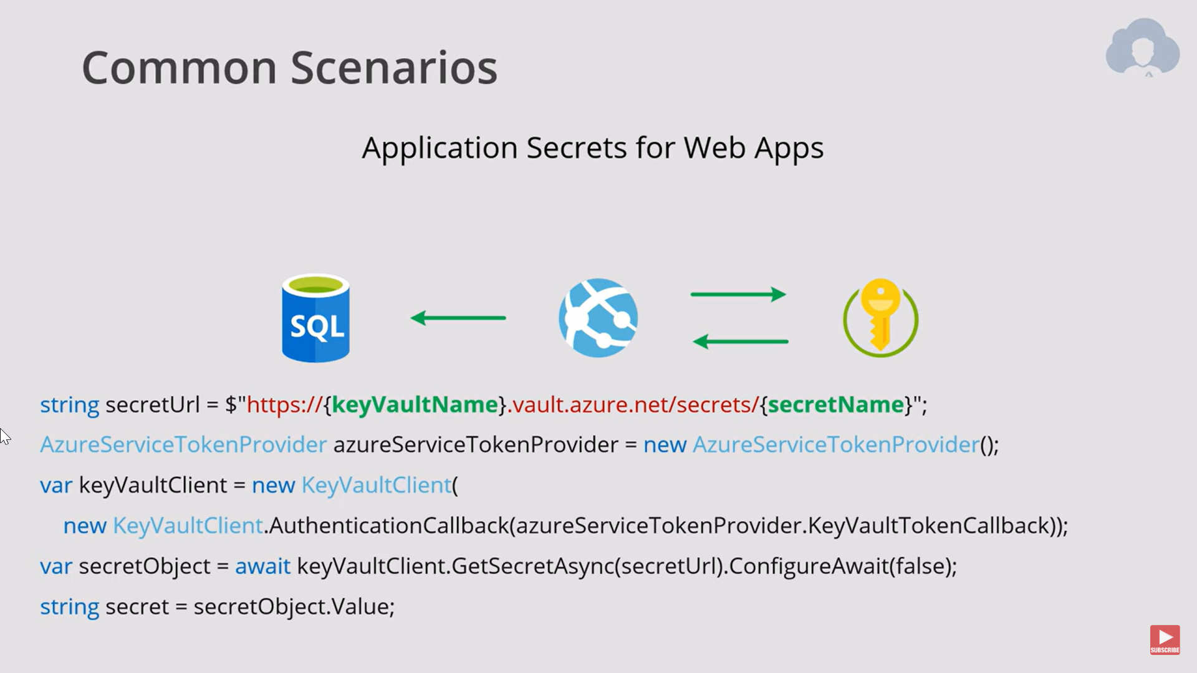

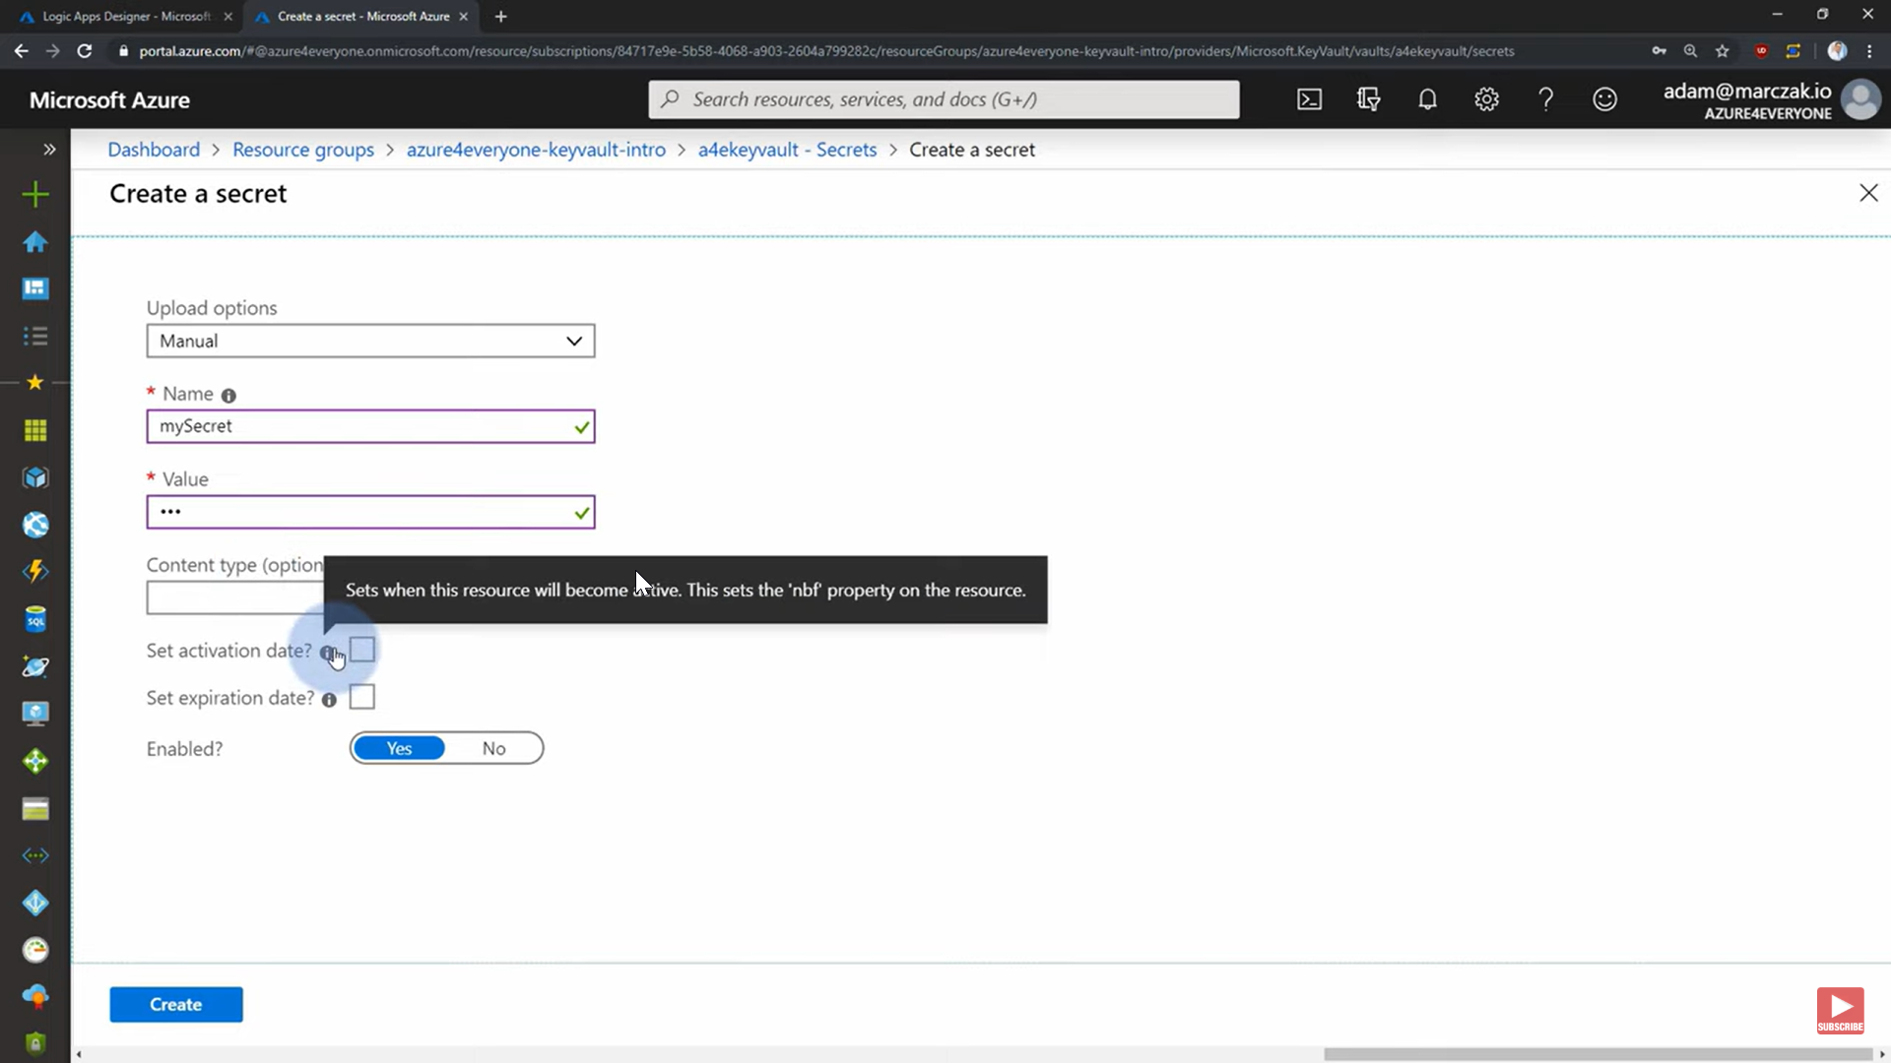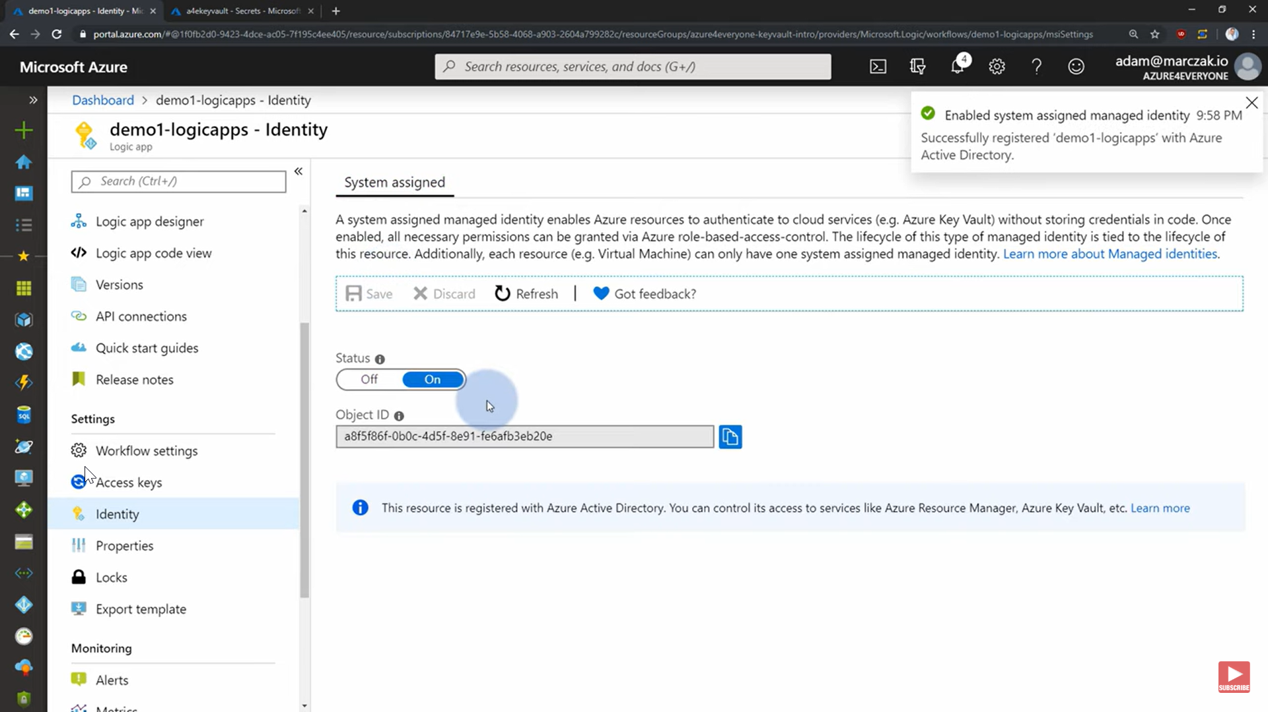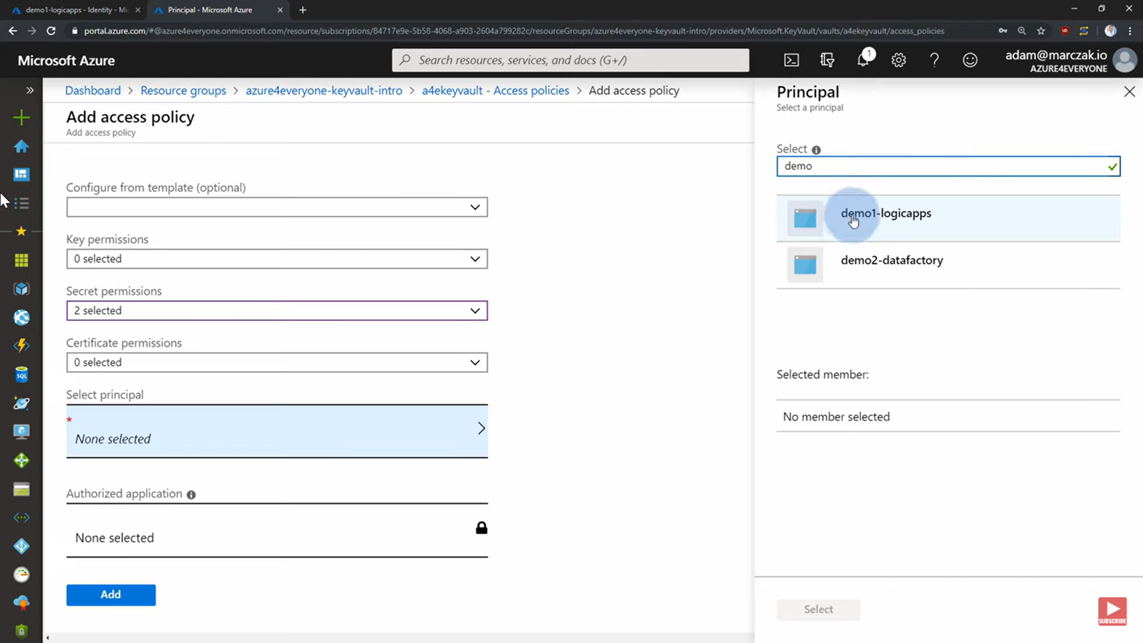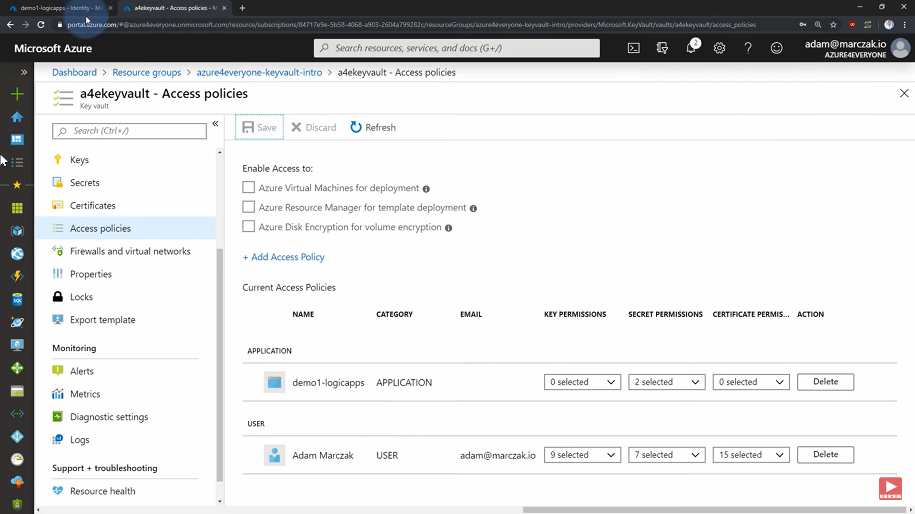

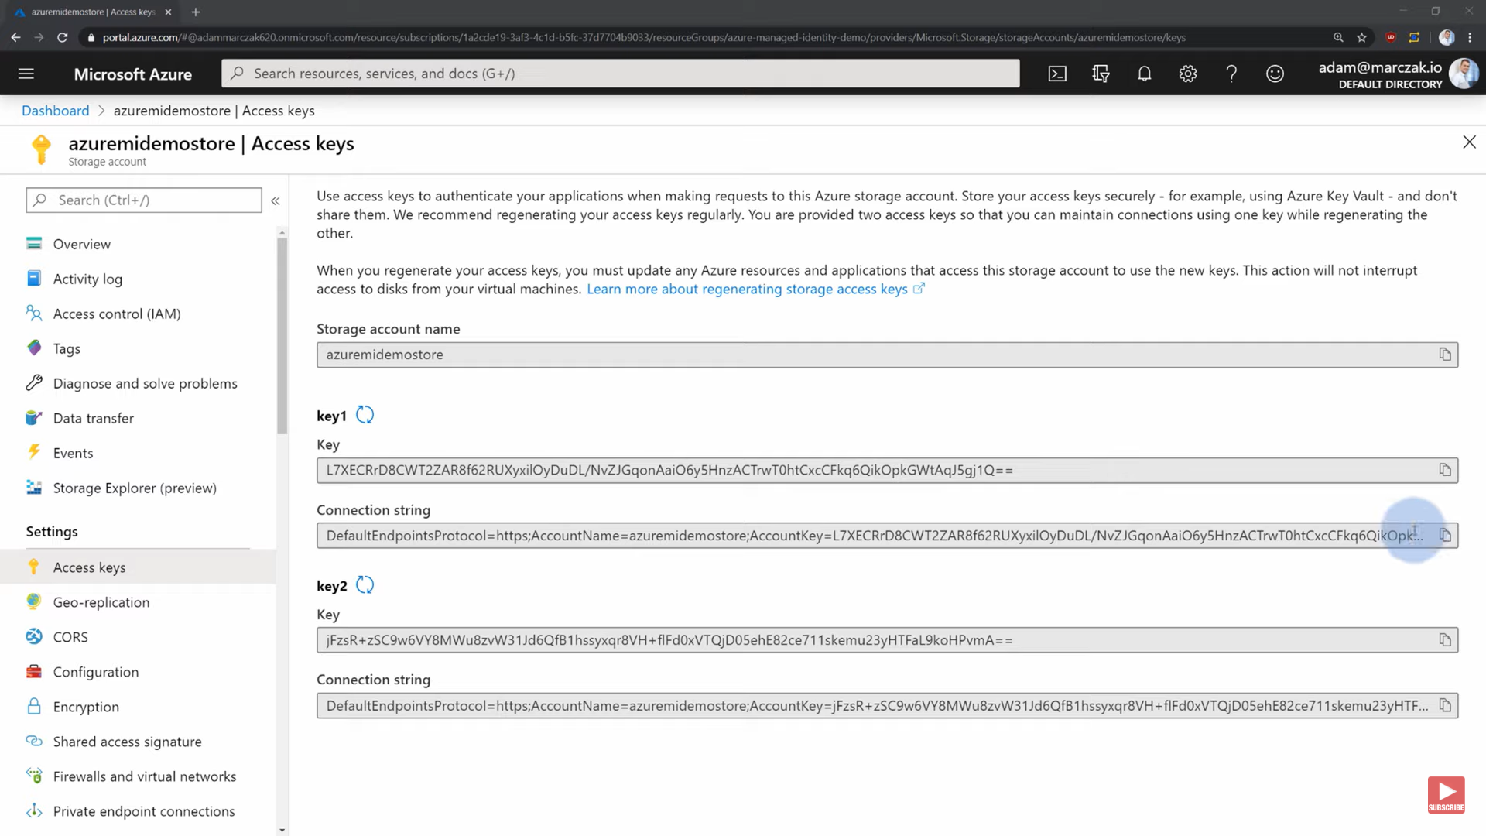

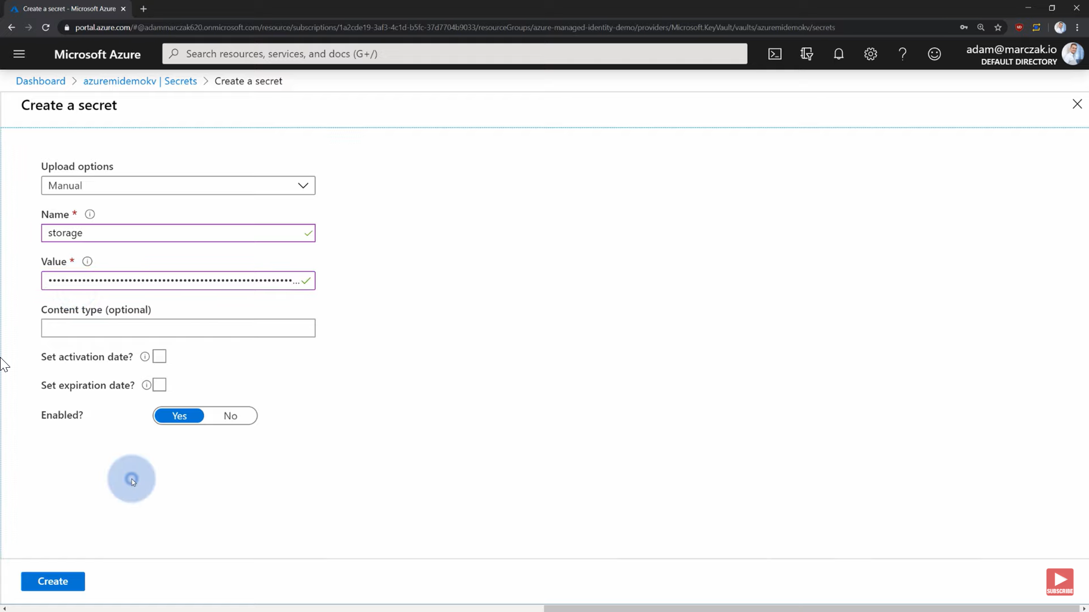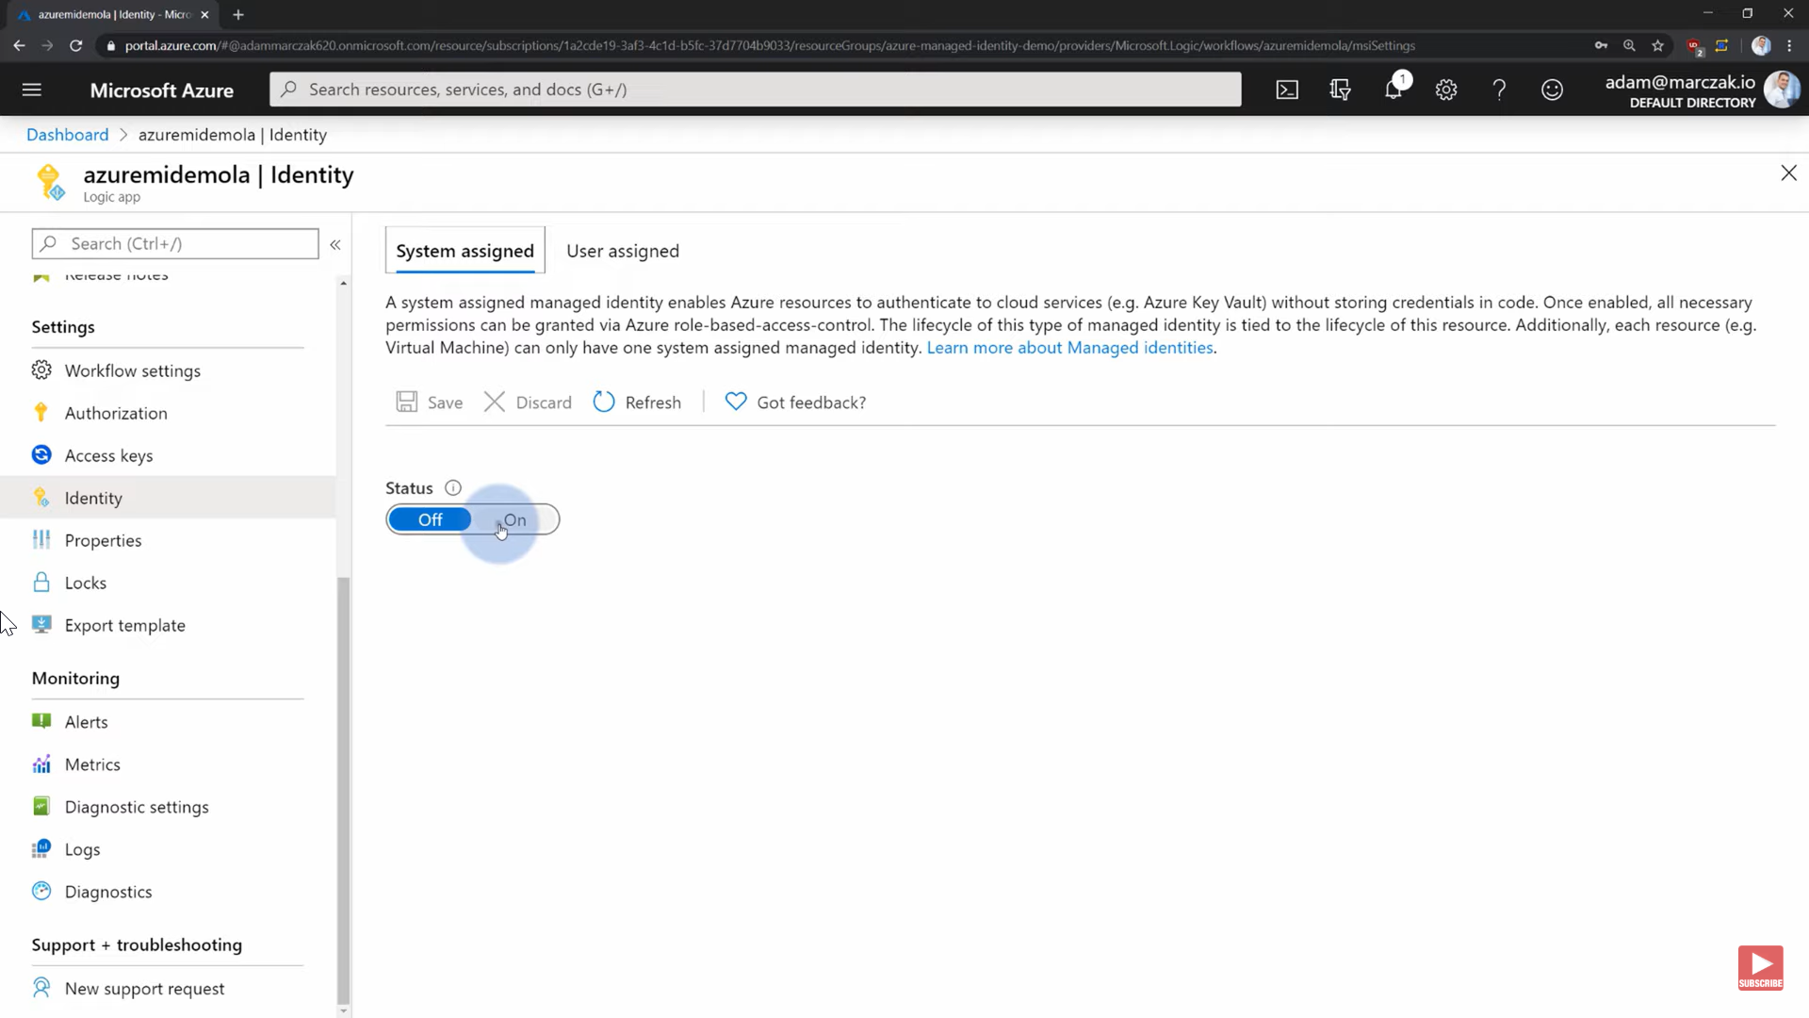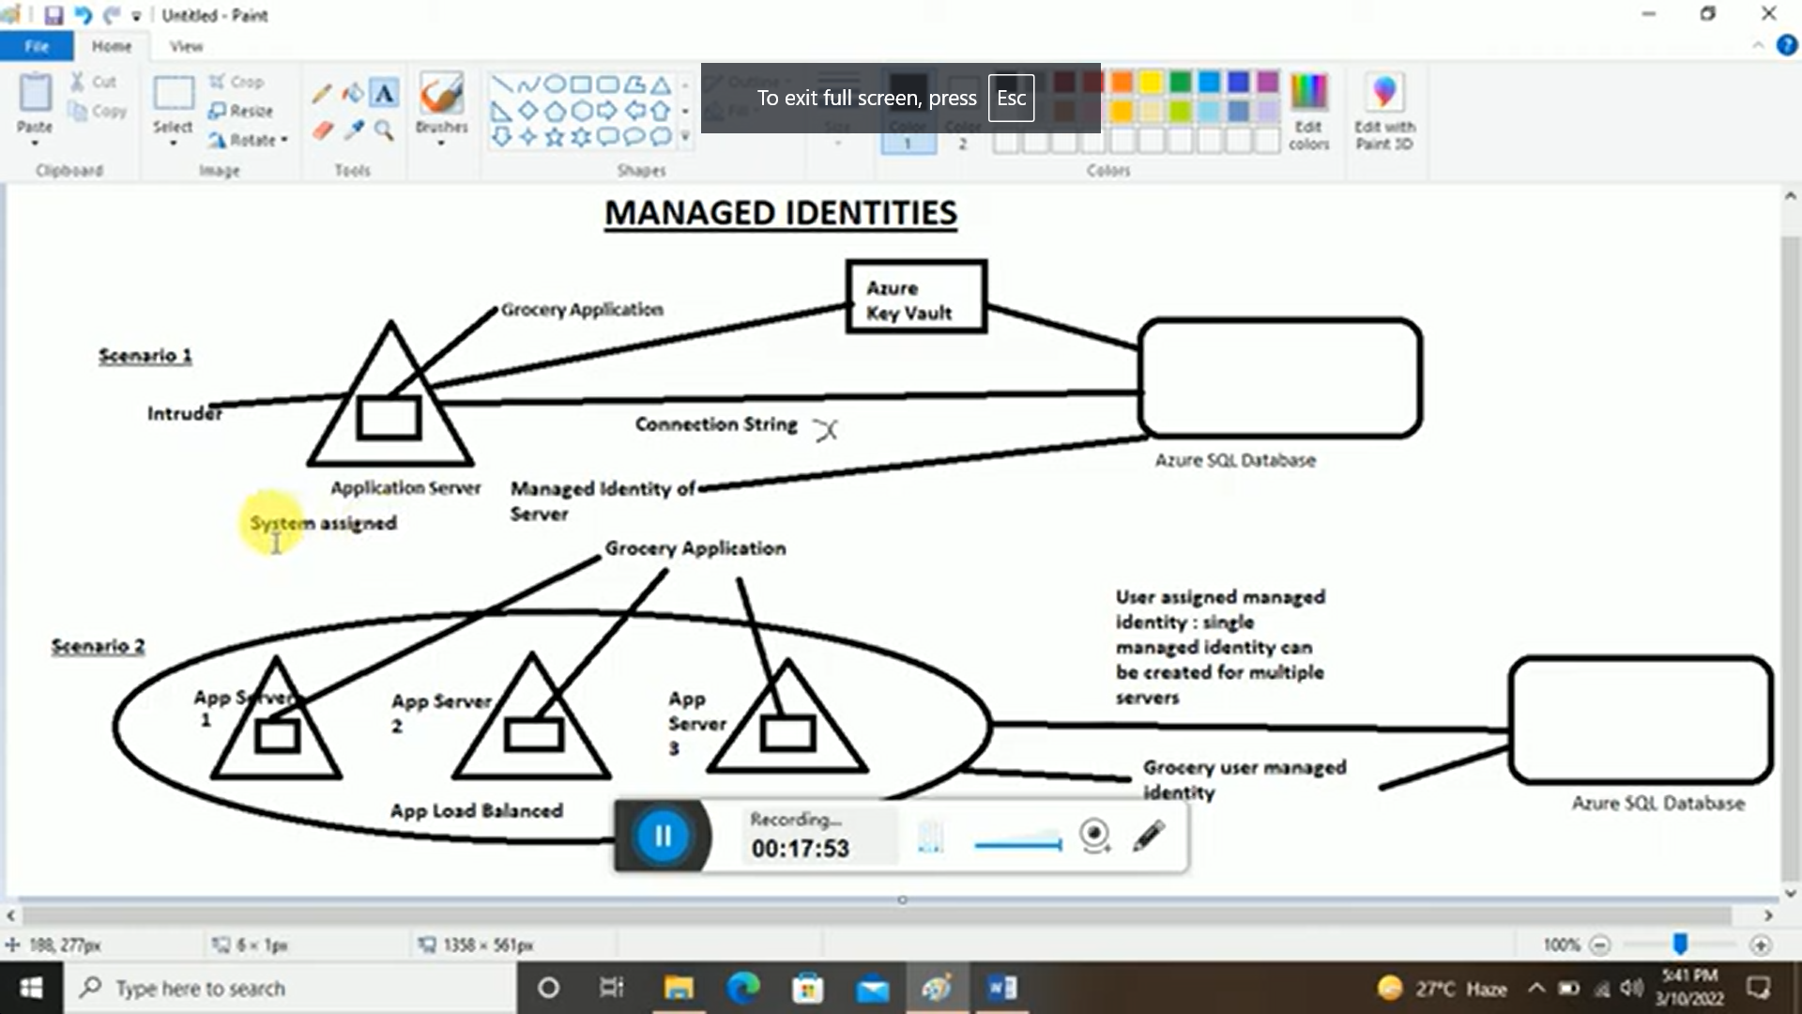

If we delete vm then

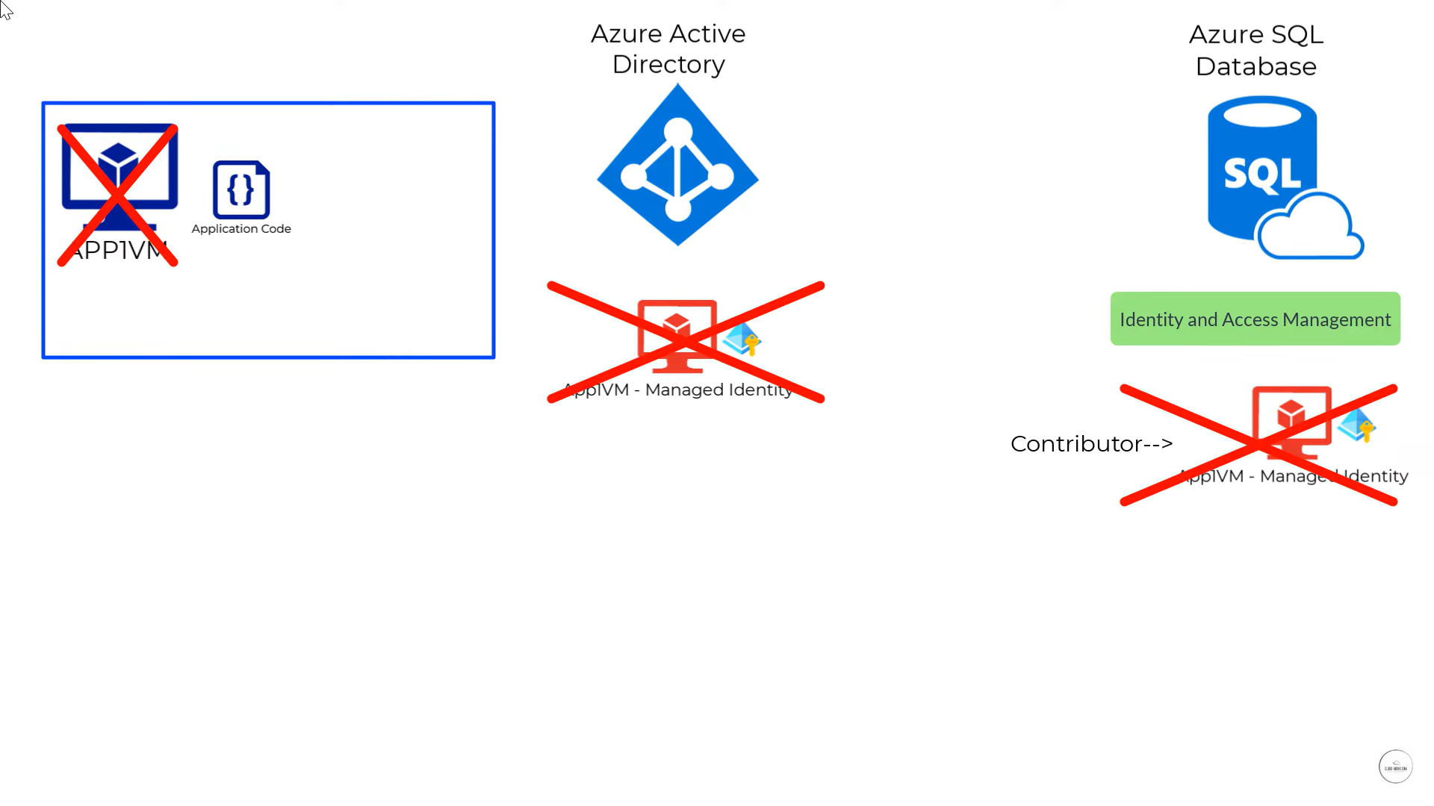

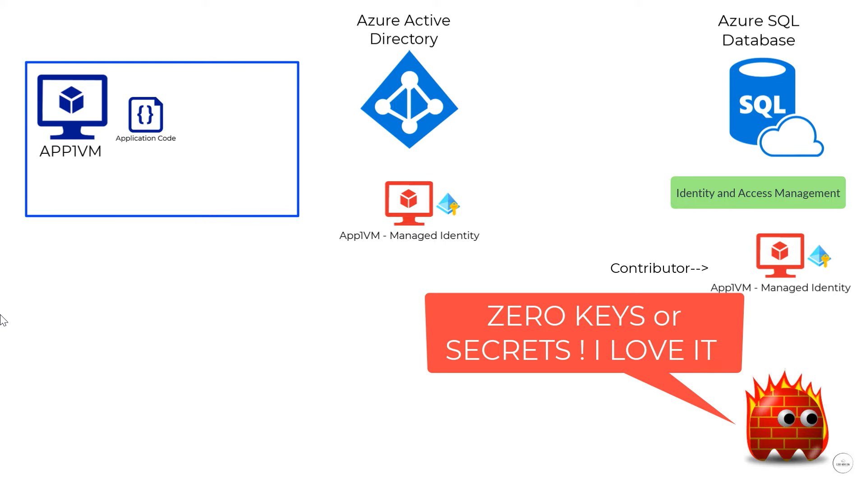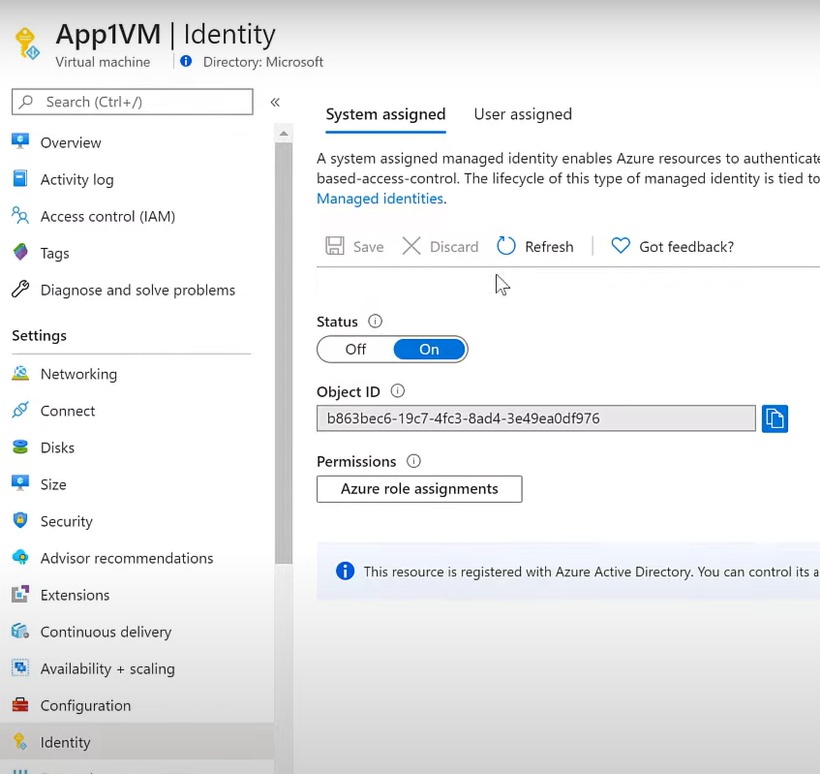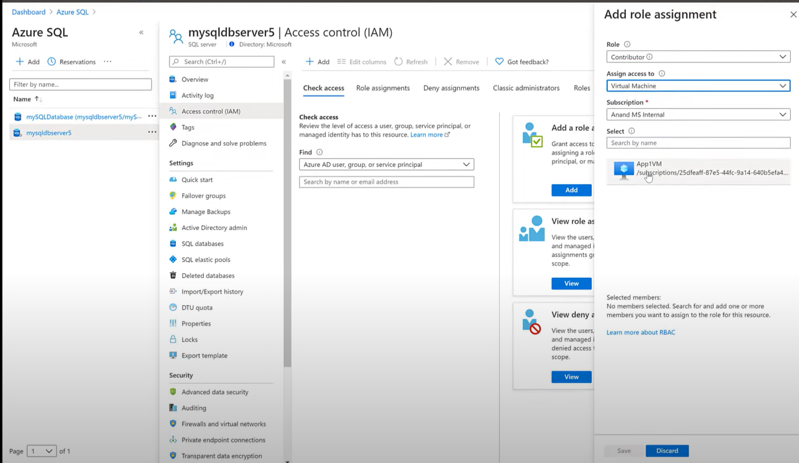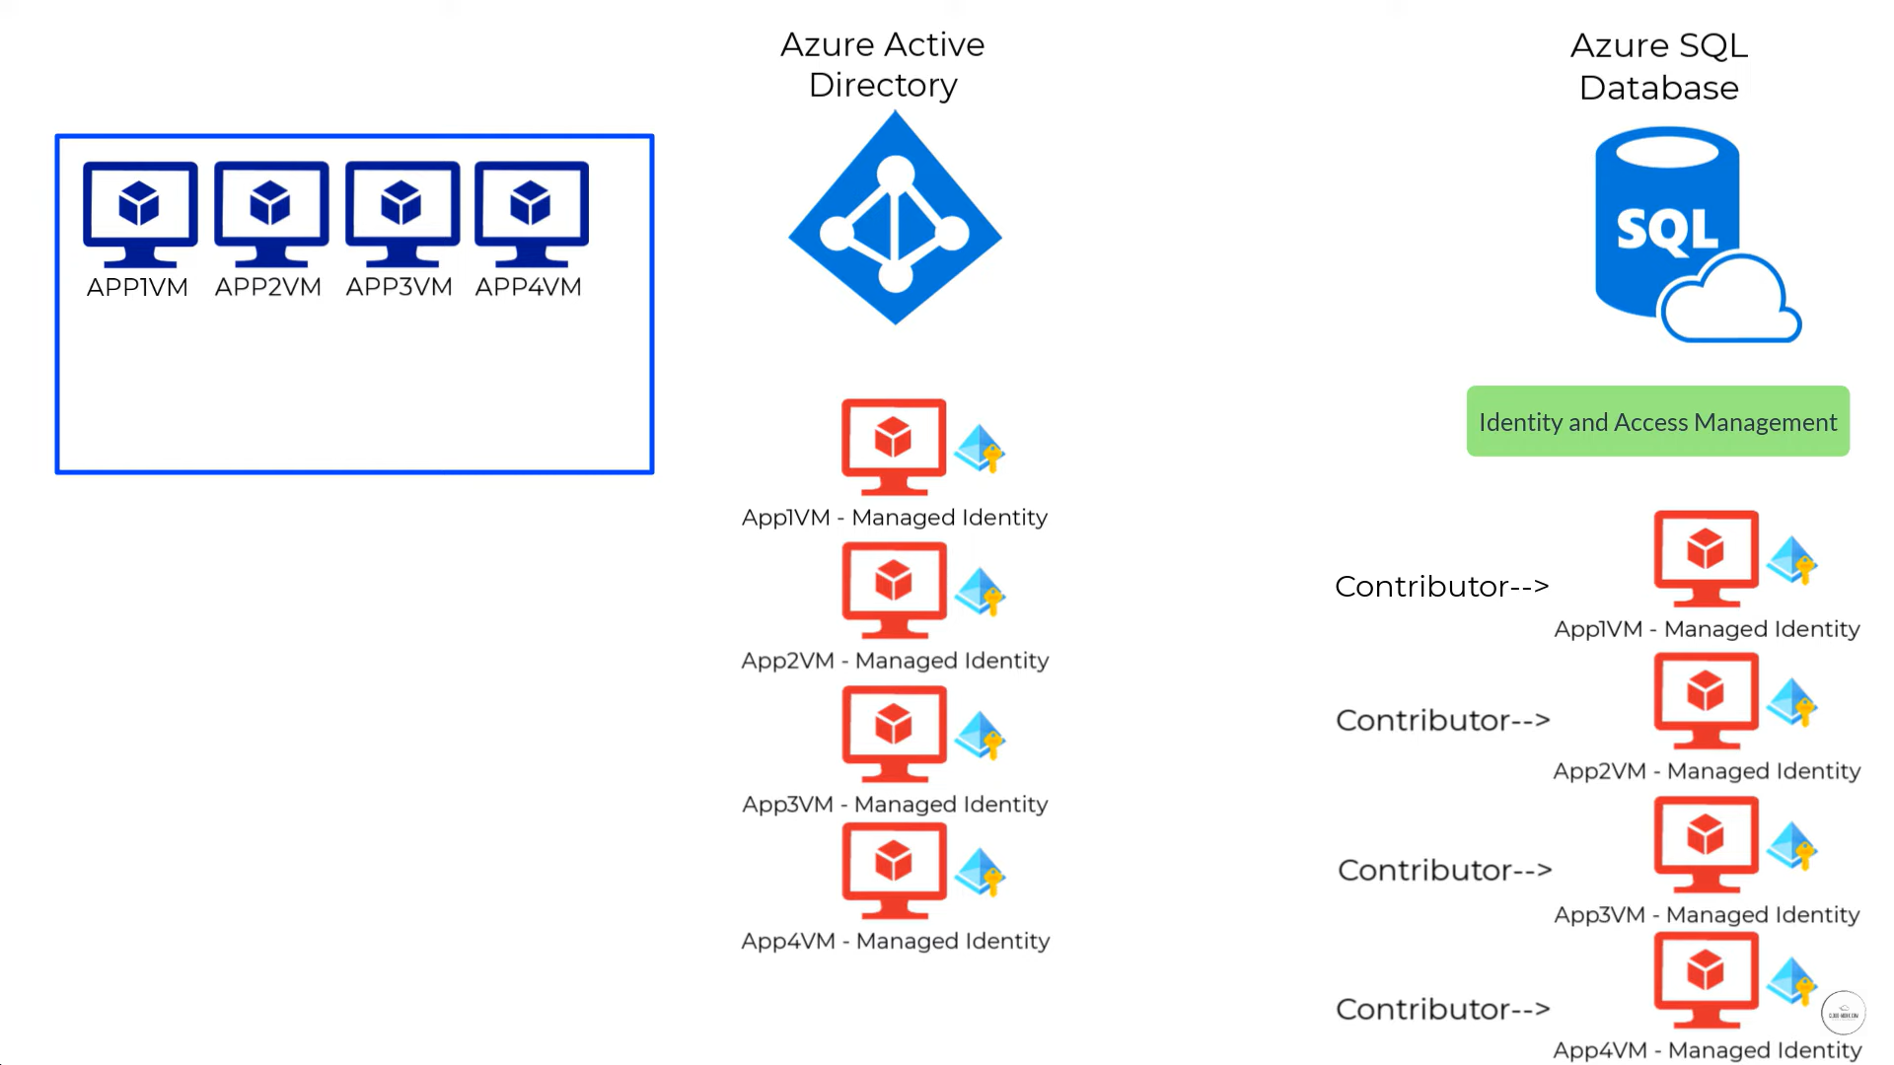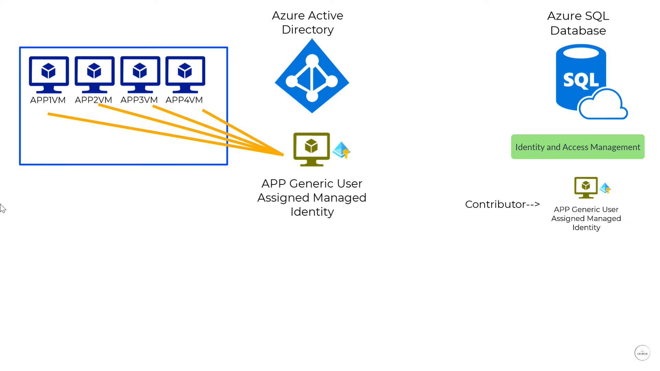

User Assigned managed identity

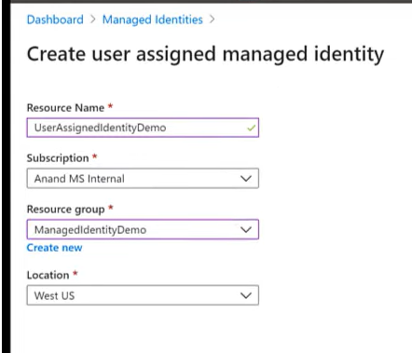

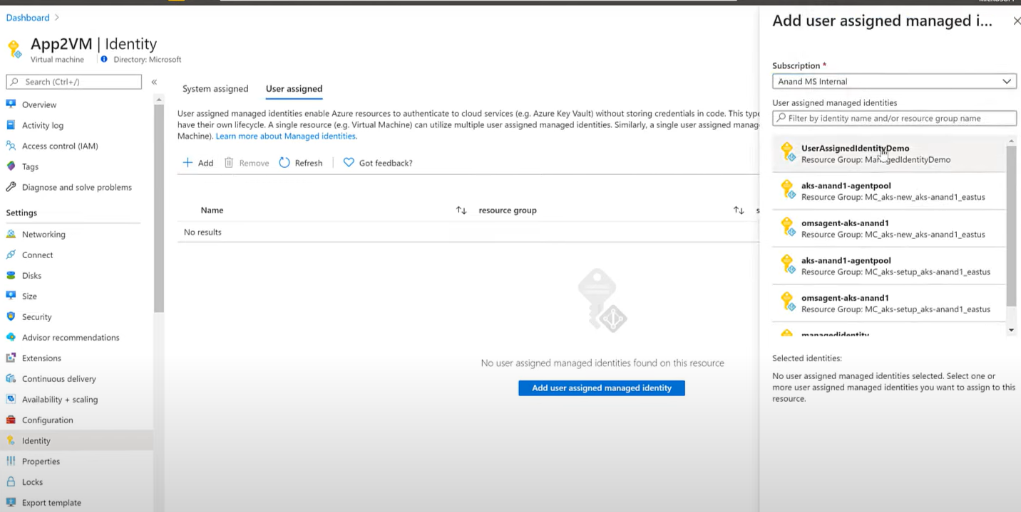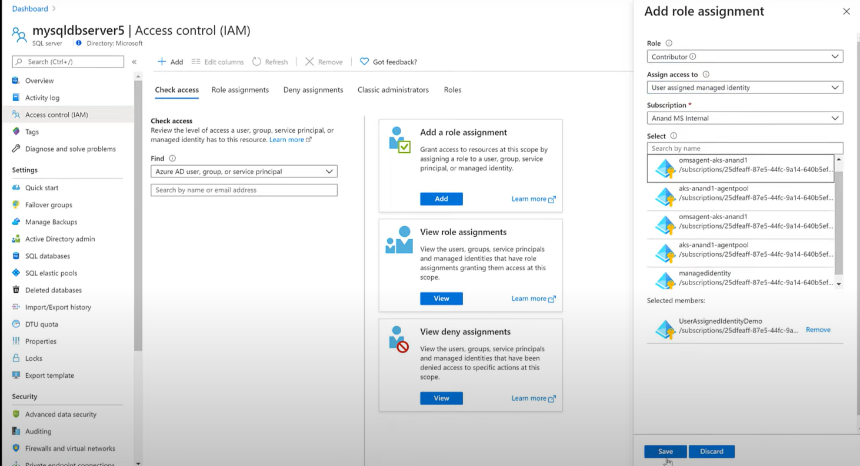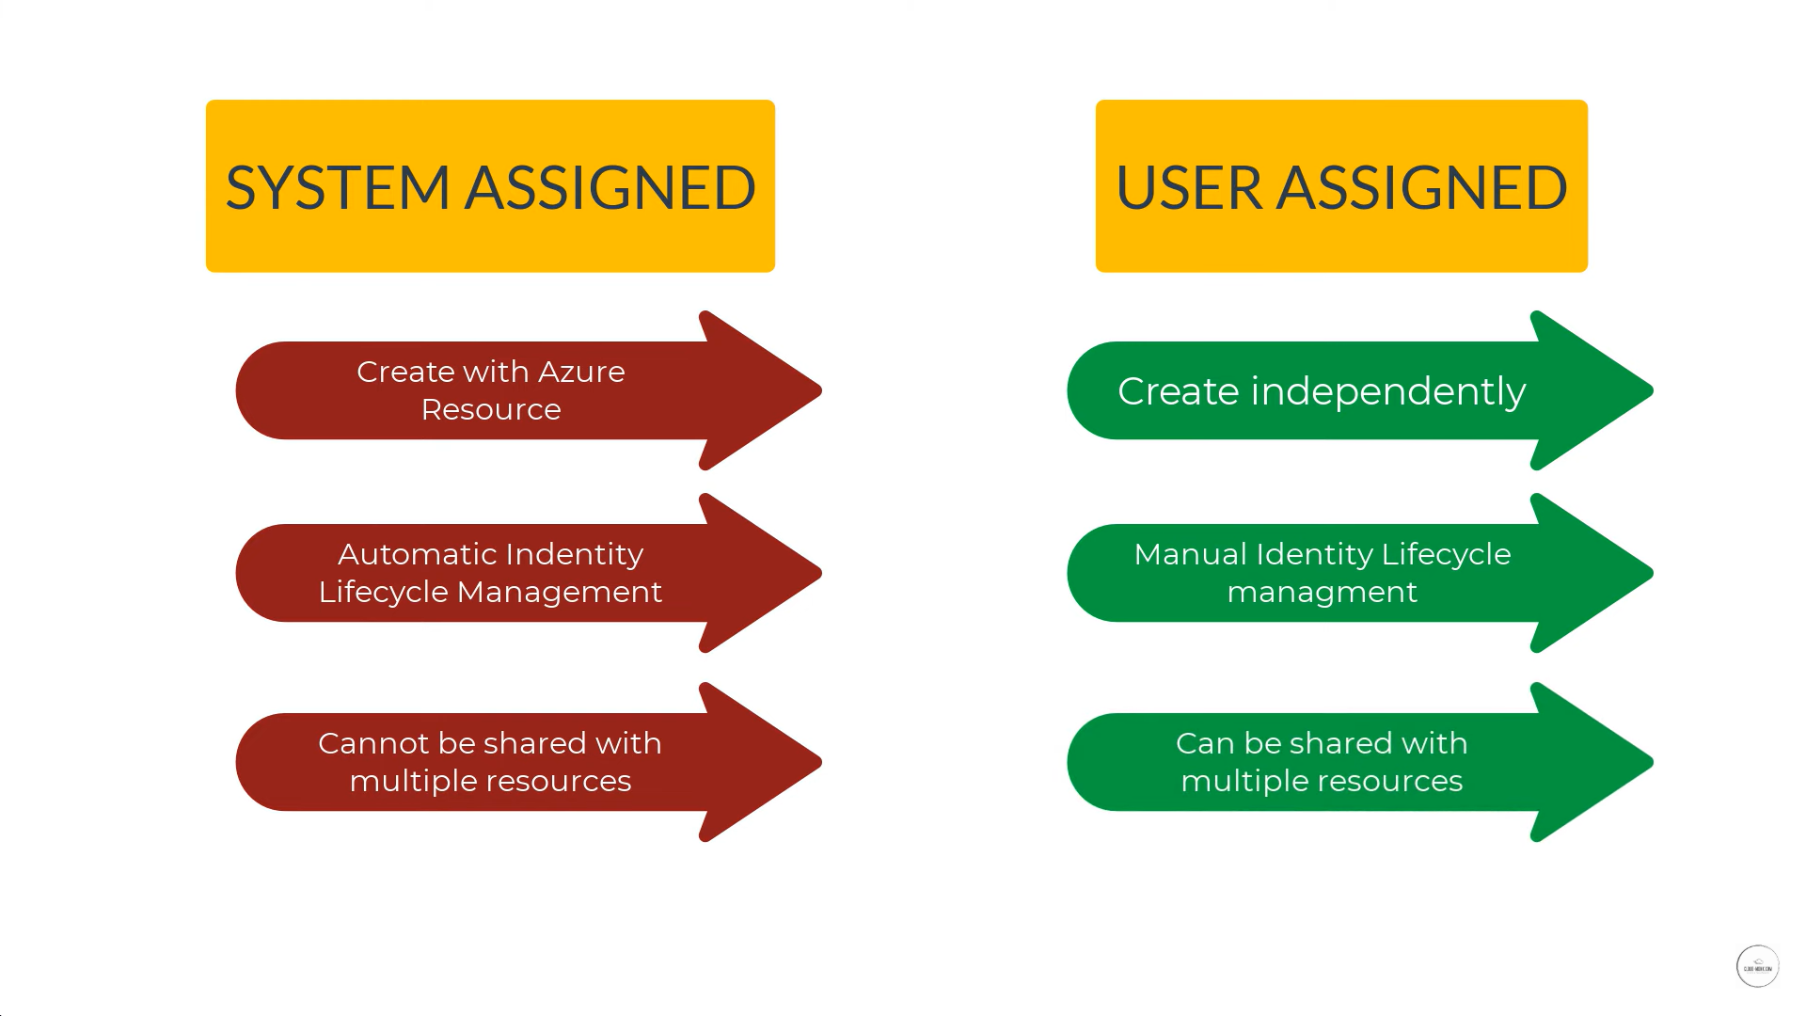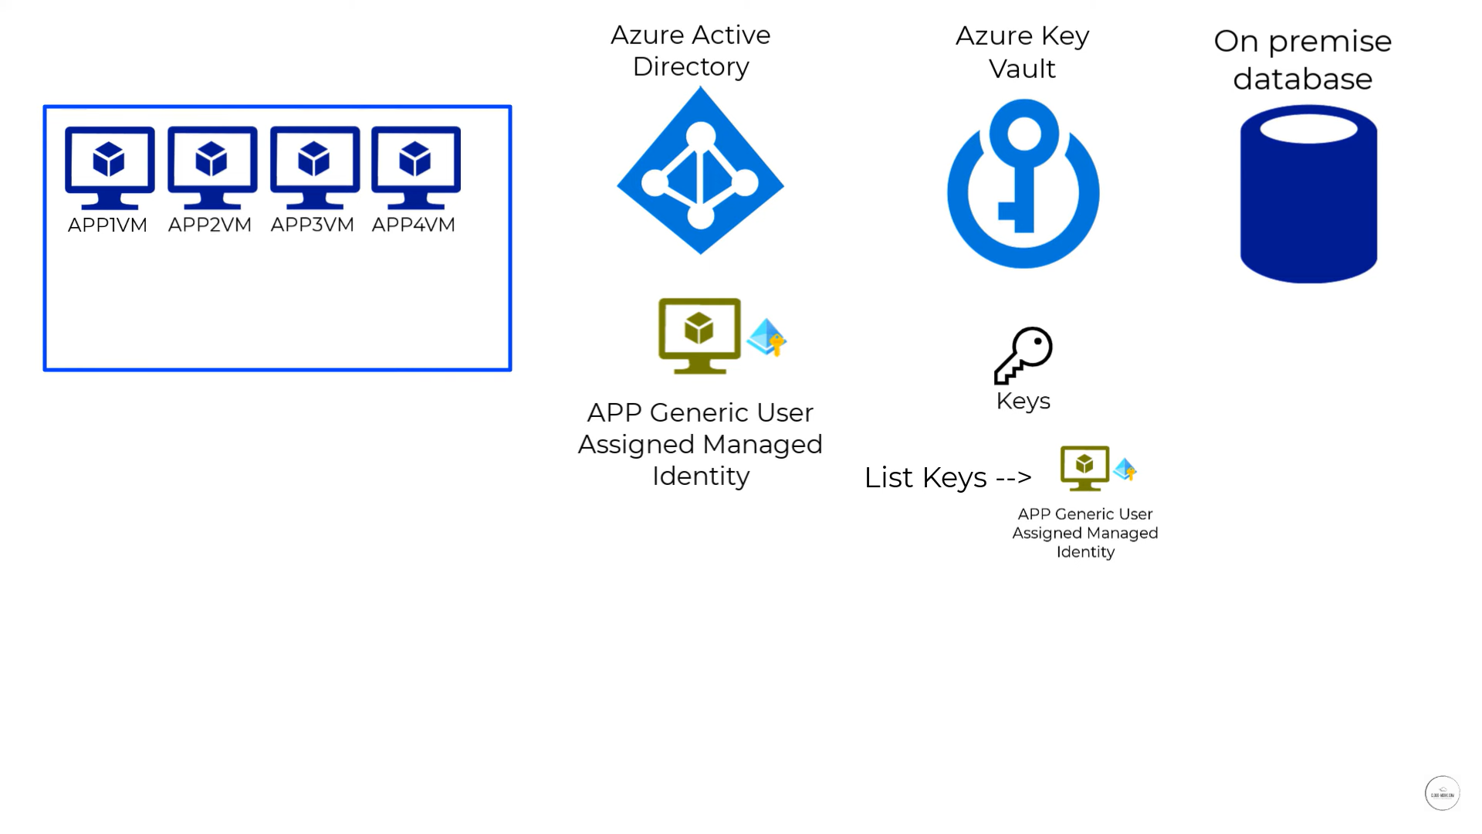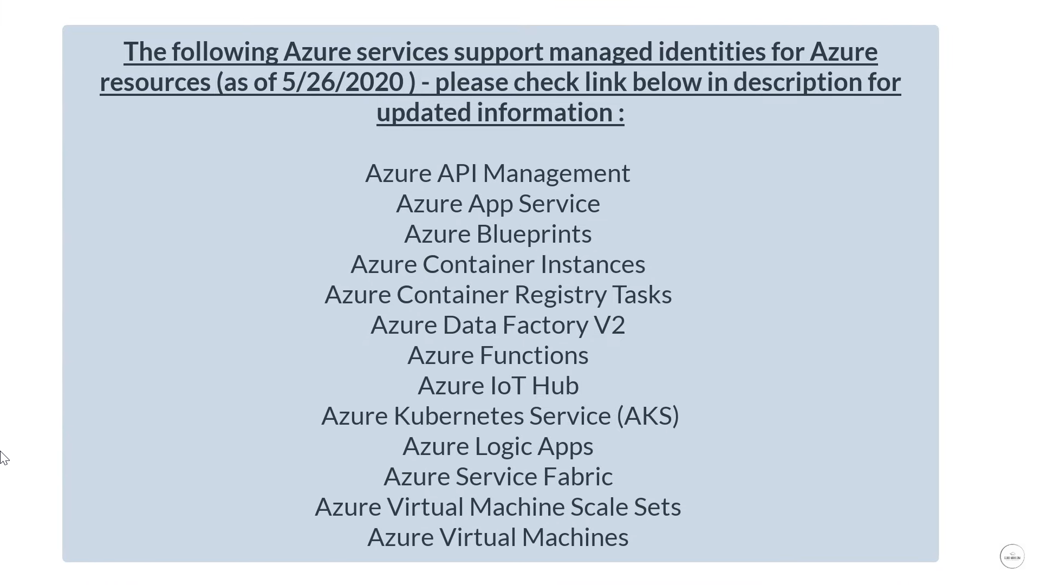

Azure Logic app

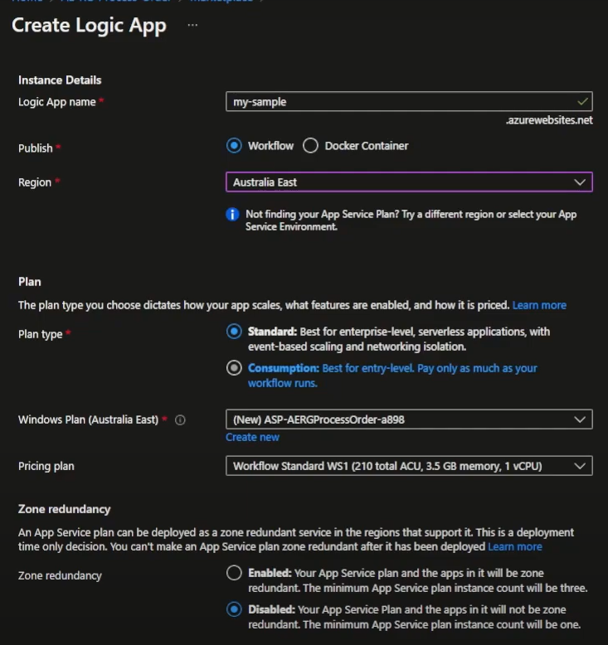

Build in Connector 🡪 Control, Data operation, Variables